Imagine you have a large supply of 3kg and 8kg weights.
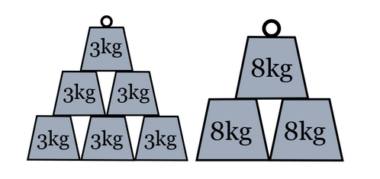

Can you see how the picture below can be used to explain why two 3kg weights and three 8kg weights have a mean weight of 6kg?

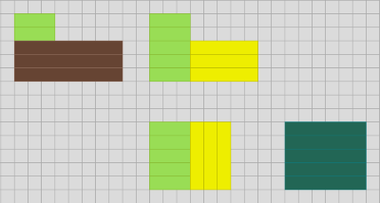

Can you find other combinations of 3kg and 8kg weights whose mean weight is a whole number of kg?
What's the smallest possible mean?
What's the largest?
Can you make all the whole numbers in between?
What if you have a different pair of weights (for example 2kg and 7kg)?
Which whole numbers is it possible to have as the mean weight now?
What do you notice about your results?
Can you use what you notice to find the combination of 17kg and 57kg weights that have a mean weight of 44kg......of 52kg.......of 21kg.....?

